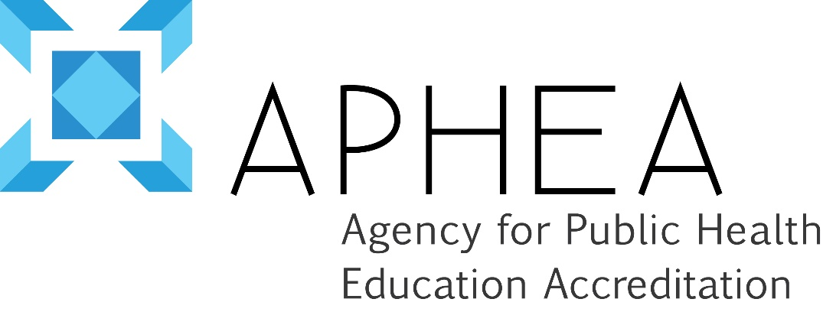

Policy Statement on Conflicts of Interest

Version 1, April 2012
The Agency for Public Health Education Accreditation (APHEA) affirms its commitment to an accreditation process that is characterized by fairness and impartiality. APHEA therefore has a duty to avoid real or perceived conflicts of interest. The potential for a conflict of interest arises when one's duty to make decisions in the public's interest is compromised by competing interests of a professional, personal or private nature.

The obligation of the individual with a conflict of interest which in any way may bias their role as a site visitor for a given programme:
- disclosure of the relationship(s) which constitute(s) or may be perceived as constituting a conflict,
- refusal to accept assignment

APHEA does not seek to exclude from participation all individuals who have or who have ever had any relationship of any nature with an institution subject to accreditation, only those that would potentially bias an accreditation decision in one way or another. To this end, the following safeguards are observed: a) an institution has the right to challenge the involvement of a proposed site visitor based on a perceived conflict of interest and b) the APHEA Board of Directors must approve all proposed site visitors for a given programme.

Numerous relationships might constitute a conflict of interest and the extent to which they do or do not constitute a conflict must be determined on an individual basis. Typical conflicts of interest, provided here as examples only, would include current or former affiliation with the programme being reviewed, affiliation with a competing institution in geographic proximity, a recent or current financial interest in the institution or its activities, alumni status at an institution or other business or professional relationships.
I have read the policy on conflicts of interest and agree to abide by its terms.

NAME (Please print):
SIGNATURE:
DATE:

