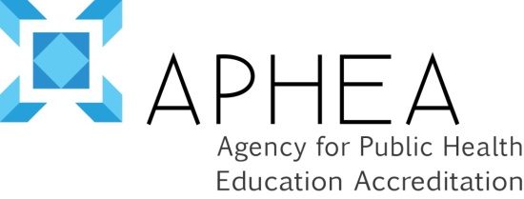

APHEA INSTITUTIONAL ACCREDITATION Evaluation

Institution visited:
Date of visit:
Your role:

We would appreciate your assigning a numerical value according to your level of satisfaction about each item according to a Likert scale:
1 = Strongly disagree
2 = Disagree
3 = Neutral
4 = Agree
5 = Strongly agree

A. PROCEDURAL ARRANGEMENTS
Value
APHEA staff managed the procedural aspects of the accreditation process - from initial notification to site-visit
Comments:

The process was consistent with information provided in the procedures manual.
Comments:

APHEA provided sufficient staff consultation throughout the process.
Comments:

Do you suggest any procedural changes? (delete as appropriate) | Yes | No
If yes, please explain:

B. SELF-EVALUATION PROCESS
Value
The self-evaluation process was beneficial to the institution’s constituents (students, faculty, administration, etc.)
Comments:

Given its benefits, the self-evaluation process required a reasonable expenditure of resources.
Comments:

The criteria provided a useful basis for organizing our self- evaluation.
Comments:

The criteria by which the institution is evaluated are appropriate, clear and fair.
Comments:

The criteria are valid indicators for judging quality of an institution?
Comments:

Do you suggest any changes in the accreditation criteria? | Yes | No
If yes, please explain:

C. ON-SITE VISIT
Value
The composition of the review team was appropriate for the evaluation of the institution.
Comments:

The team was sufficiently prepared to conduct the on-site evaluation of our institution.
Comments:

The site visitors addressed the major issues and problems identified in our self-evaluation during the on-site interviews.
Comments:

Do you suggest any changes in the structure or conduct of the visit? (delete as appropriate) | Yes | No
If yes, please explain:

D. OVERALL EVALUATION
Value
The final oral presentation gave an accurate and fair representation of our institution.
Comments:

In what specific ways were the self-evaluation process and on-site visit beneficial to your school or programme?
Comments:

In what ways were they not beneficial?
Comments:

Please provide any additional comments you wish to make about the accreditation process.
Comments:

Thank you very much for your comments!
©APHEA 2014

